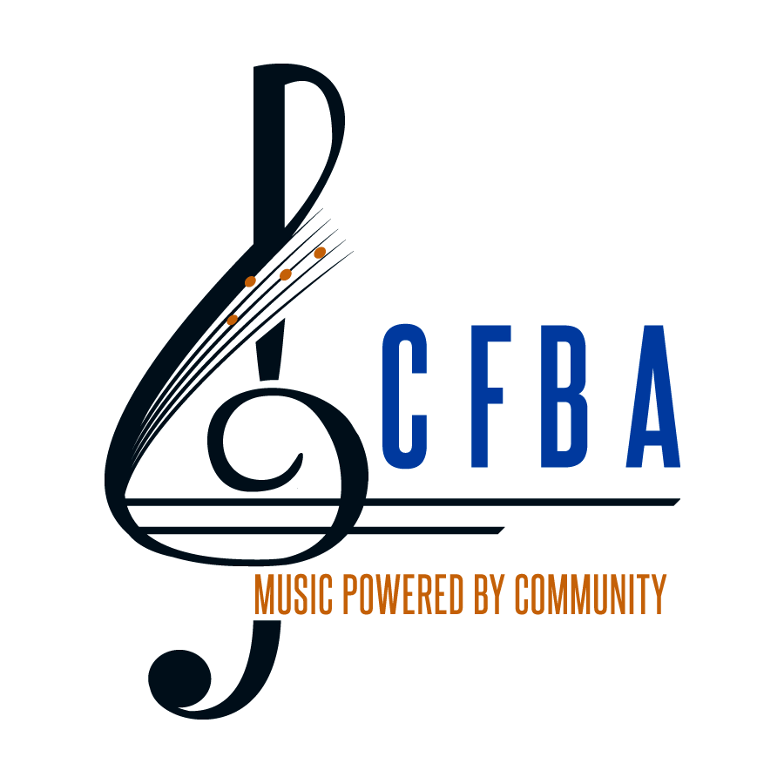
The City of Fairfax Band
Robert Pouliot, Music Director
2019 Young Artist Competition
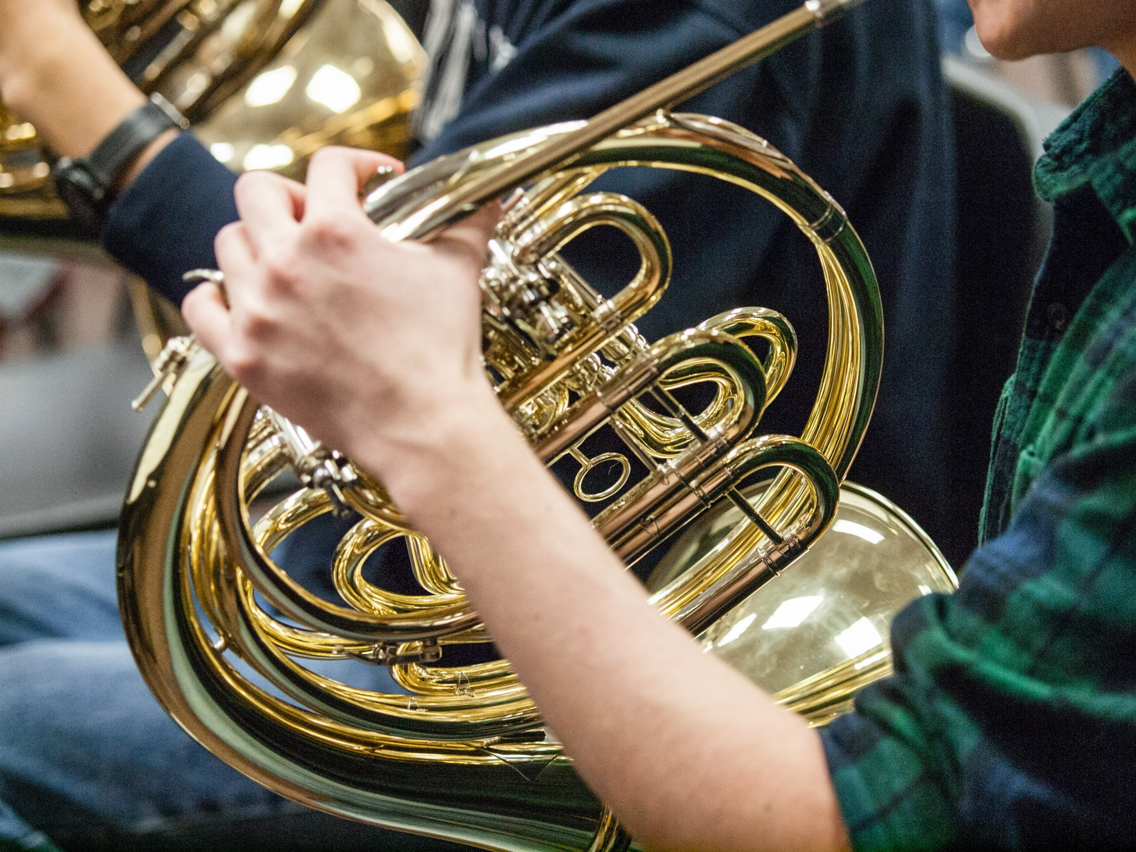
Prize
$2000 cash award and a
solo performance with
the City of Fairfax Band
Eligibility
Northern Virginia High School Juniors and Seniors
Important Dates
Application Deadline: February 15, 2019
Finalists Recital: Sunday, March 10, 2019*
(Old Town Hall, Fairfax, 7:00pm)
Young Artist Concert Appearance: Saturday, May 4, 2019*
(Ernst Community Cultural Center, NVCC Annandale Campus, 7:30pm)

Complete Rules and Eligibility: www.fairfaxband.org

*Applicants must certify availability for finals and concert date at time of application

